Bonfire Word Search
Find the missing word
R | O | M | A | N | C | A | N | D | L | E | S | S | Z | S
F | J | R | P | C | Y | M | Y | C | V | E | P | T | L | F
S | I | F | L | A | M | E | S | D | K | A | F | E | F | I
O | R | R | W | E | X | P | V | W | R | J | E | K | L | R
F | B | A | E | L | Q | K | A | K | S | H | S | C | A | E
V | P | J | T | C | P | F | L | E | W | P | V | O | R | W
S | W | O | H | S | R | E | G | E | U | Y | A | R | E | O
N | P | B | N | I | R | A | N | E | U | F | W | R | I | R
R | K | R | L | S | W | I | C | G | R | Y | R | T | K | K
U | H | D | Z | B | R | P | Q | K | L | I | J | Q | B | S
B | W | G | A | E | U | L | I | D | E | P | F | D | L | P
I | Y | N | H | I | J | U | I | A | W | R | Z | N | D | T
P | G | T | R | E | B | M | E | V | O | N | S | G | O | C
S | A | S | H | P | B | B | W | G | C | A | X | O | E | B
C | K | I | W | S | H | D | E | W | A | S | J | O | I | E

BANGS | BONFIRE | BURN
CATHERINEWHEELS | FAWKES | FIRECRACKERS
FIREWORKS | FLAMES | FLARE
GUNPOWDER | GUY | NOVEMBER
ROCKETS | ROMANCANDLES | SHOWS
SPARKLERS | SPARKS | STARS

Bonfire Word Scramble
Unscramble the below to find the Halloween words
ERIWKFRO
SNOILXPOE
SKRCTEO
SAKLSRERP
HANTERCEI SHEEWL
IBEORFN
ANEGSRB
VBMOENER
UYG EKFAWS
PNUWEGROD
ORANM ADLSCNE

Answers: Firework; Explosion; Rockets; Sparklers; Catherine Wheels; Bonfire; Bangers; November; Guy Fawkes; Gunpowder; Roman Candles
Bonfire Crossword
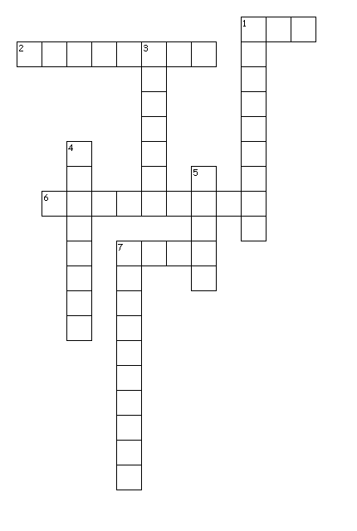
Across
1. Fawkes name of the leader (3,5)
2. Month we celebrate Bonfire Night
6. __________Wheel, Firework
7. The Gunpowder__________

Down
1. An explosion powder used to make fireworks and bombs
3. We build, light and throw the guy on this
4. Fireworks you can write your name in the air with
5. Day of the month Bonfire Night Happens
7. The building that was nearly blown up

Answers: Halloween; 1. Guy Fawkes, 2. November, 3. Bonfire, 4. Sparklers, 5. Fifth, 6. Catherine, 7. Parliament, 7. Plot

